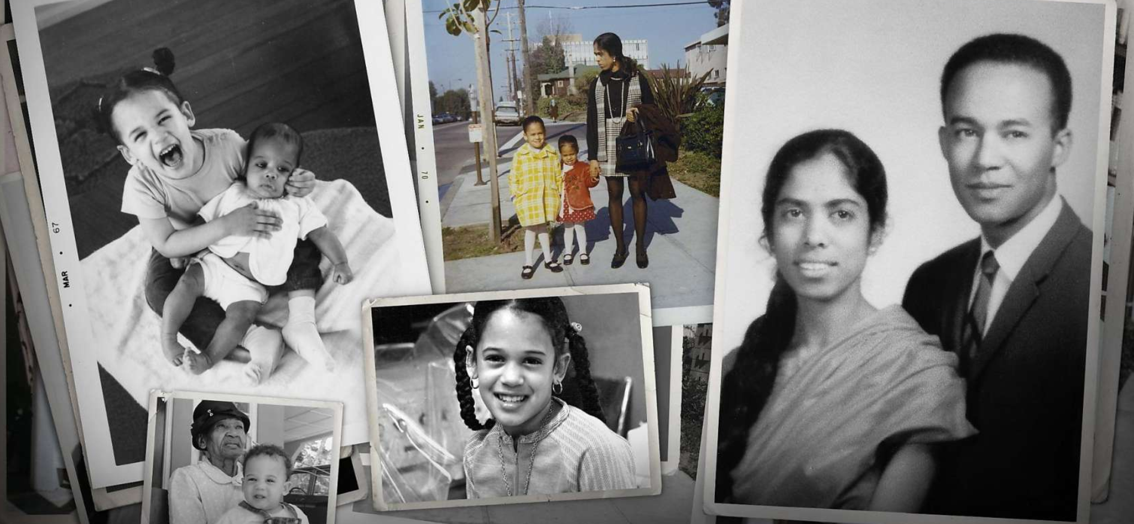
Kamala Harris Shaped by Berkeley
and a ‘Do Something’ Mother

Much of who Kamala Harris is today traces back to her childhood in Berkeley in the 1960s and early ’70s, and a mother who taught her it wasn’t enough just to complain about the way things were.
By Tal Kopan | Aug. 16, 2020
WASHINGTON — When Kamala Harris wants to make a particularly strong point, there’s one person she almost always quotes: her mother.
The California senator cited her late mother, Shyamala Gopalan Harris, in her first public appearance last week as Joe Biden’s vice presidential nominee-to-be. Gopalan shows up on more than 30 pages of Harris’ 2019 autobiography, “The Truths We Hold.” Her mother’s words of advice and wisdom were an integral part of Harris’ stump speeches when she was running her own presidential campaign last year.
It’s a reflection of what Harris and those who know her best will readily say: Much of who she is today traces back to her childhood in Berkeley in the 1960s and early ’70s, and the example Gopalan set as a trailblazing scientist and single mother.
Oakland Mayor Libby Schaaf, a fellow daughter of the East Bay in that era, said she sees the influence of Harris’ mother and upbringing in the area in her longtime friend, both as a person and as a politician.
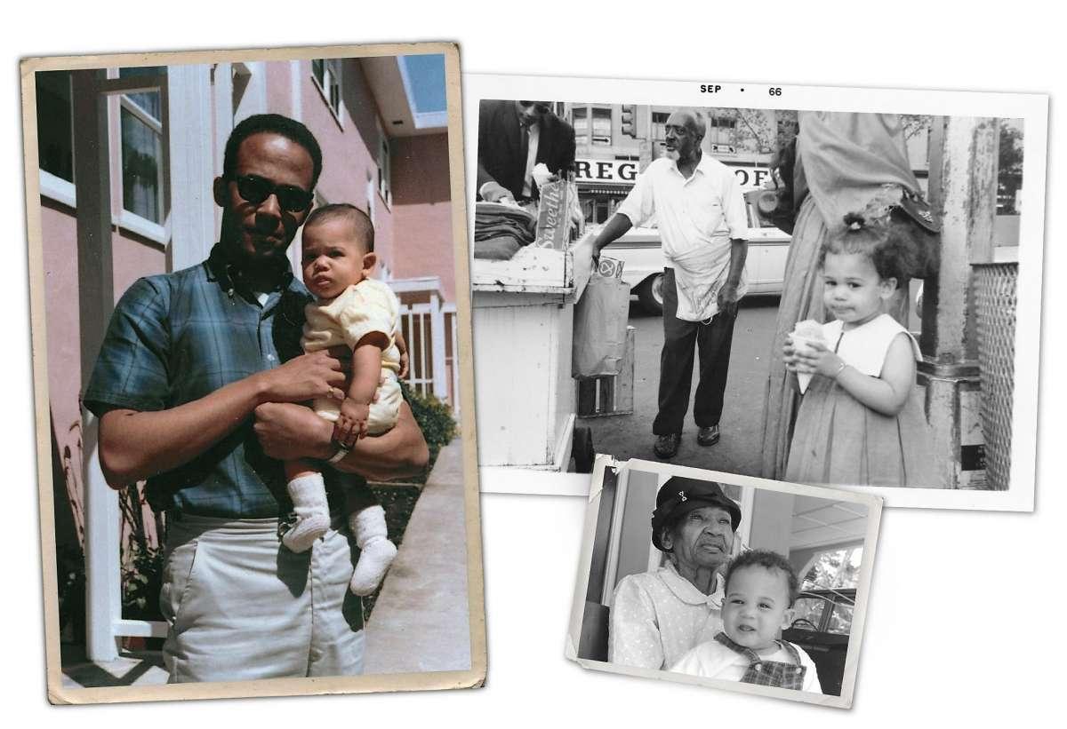
“When we look at (House Speaker) Nancy Pelosi, Kamala Harris, women who have survived the crucible of Bay Area politics — yeah, you don’t just have tough skin, you have Teflon armor,” Schaaf said. “You see that rare combination of kindness and compassion and no hesitation to gut your opponent. ... Her ability to just drill down to the truth, to not suffer fools, to advance unapologetically an agenda in the face of criticism — that is Bay Area street tough at its finest.”
In this April 1965 photo provided by the Kamala Harris campaign, Donald Harris holds his daughter, Kamala. This September 1966 photo provided by the Kamala Harris campaign shows her during a family visit to the Harlem neighborhood of New York. In this undated photo provided by the Kamala Harris campaign in April 2019, Iris Finegan holds her great granddaughter, Kamala Harris, in Jamaica. Photo: Chronicle Photo Collages With Images From Kamala Harris Campaign Via AP
Harris, 55, was born to Gopalan, an Indian immigrant who came to the U.S. by herself at age 19, and a Jamaican immigrant father when both were graduate students at UC Berkeley in 1964. The couple fell in love while participating in the active local civil rights movement, and Harris was often brought along for the ride — literally.
“That’s how they met — as students, in the streets of Oakland, marching and shouting for this thing called justice, in a struggle that continues to this day,” Harris said in her first public remarks Wednesday as Biden’s running mate. “And I was part of it. My parents would bring me to protests — strapped tightly in my stroller.”
Harris added that as she grew, her mother would encourage that same activism in her: “She’d tell us, ‘Don’t just sit around and complain about things. Do something.’”
Her mother and father divorced when Harris was 7, with Gopalan taking primary custody of her and her younger sister, Maya. They lived in the flatlands of west Berkeley. Her father, Donald Harris, remains an economist and professor emeritus at Stanford University.
MORE INFORMATION
Kamala Devi Harris at a glance:
Date of birth: Oct. 20, 1964, in Oakland.
Education: Bachelor’s degree from Howard University, 1986. Earned her law degree from UC Hastings College of the Law in 1989.
Career: Deputy district attorney of Alameda County, 1990-98. San Francisco District Attorney’s Office managing attorney and chief of San Francisco City Attorney’s Office division on children and families, 1998-2004. San Francisco district attorney, 2004-11. California attorney general, 2011-16. U.S. senator, 2016-present.
Family: Married to Douglas Emhoff, a Los Angeles attorney. They have two children from his previous marriage.
While not entirely estranged from her father, Harris was much closer to her mother, and it was her influence that shaped the future senator. Harris wrote in her book that she would see her father on weekends and in the summers, but lived with her mother and built the strongest ties with Gopalan’s close friends here and her family in India.
Gopalan, a breast cancer researcher, died in 2009.
“Shyamala was a doctor. She was just like Kamala: super smart, super determined to live out her values, and incredibly kind and compassionate,” said Schaaf, whose mother was friends with Gopalan. “I like to think both of us were blessed with mothers who were nurturing, but also fierce in their values and unafraid to show their intelligence.”
Schaaf was with Harris the night she was elected to the Senate in 2016. “We just had a little moment with both of us in tears in our eyes,” Schaaf said, “and I said, ‘I wish your mom was here. She would be so proud of you right now.’”
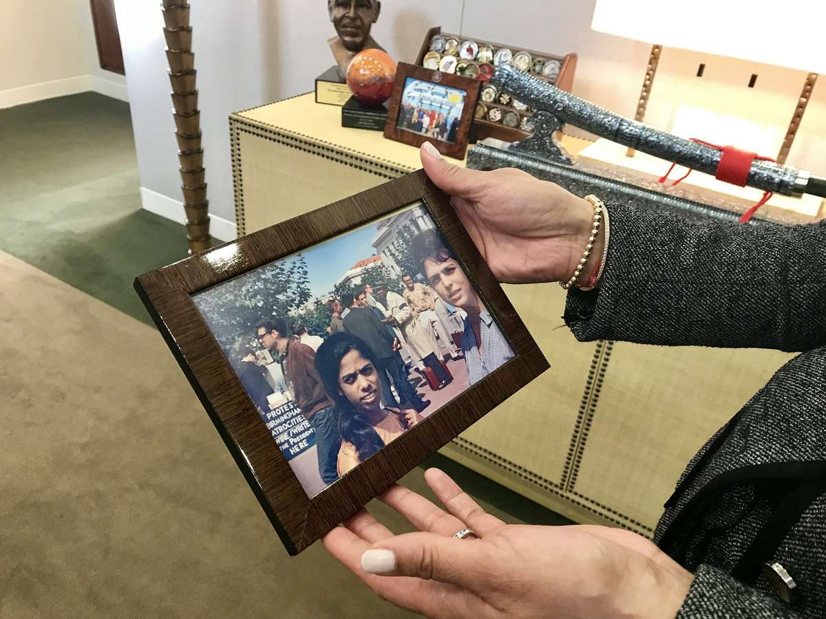
In her Washington Senate office in 2018, Harris holds a picture of her mother, Shyamala Gopalan Harris, whose civil rights activism in the 1960s influenced the future leader. Photo: Tal Kopan / The Chronicle 2018
One of Harris’ prized possessions is a photograph of her mother and a friend as young women on the UC Berkeley campus in the early 1960s. In the background are people wearing black armbands, often a symbol of protest and mourning for ’60s activists. A sign refers to Birmingham, Ala., a focal point of the civil rights movement. The photo was dropped off at her Senate office by a man who didn’t leave his name — to this day, Harris doesn’t know who he was.
“I talk a lot about my mother,” Harris said in a 2018 interview with The Chronicle in her office, as she held the picture. “So this is, I think, my favorite thing on this desk.”
A former colleague of Gopalan’s at Lawrence Berkeley National Laboratory, Mina Bissell, recalled her as strong, principled, brave, thoughtful, “very fierce” and independent. She sees much of Gopalan in Harris — like her mother, she said, Harris places immense value on education, hard work and self-sufficiency.
Gopalan “was very competent and very opinionated, but scientifically,” Bissell said. She was a “mom who was powerful and thoughtful and very-education oriented, very warm with her children.”
The two women met when Harris and Bissell’s daughter, Yalda, were in ballet together and bonded because both their mothers were scientists. Bissell recalled that she and Gopalan were once finalists for a job opening, but said it turned out they were being interviewed only so the hiring managers could tell the government grant-writers they had considered women for the position. She described encountering a “terrible chauvinist” in the hiring process who demeaned her. The job went to a man.
It was emblematic of the time, Bissell said, when women in science had to navigate a field in which the men who dominated it were often dismissive of them.
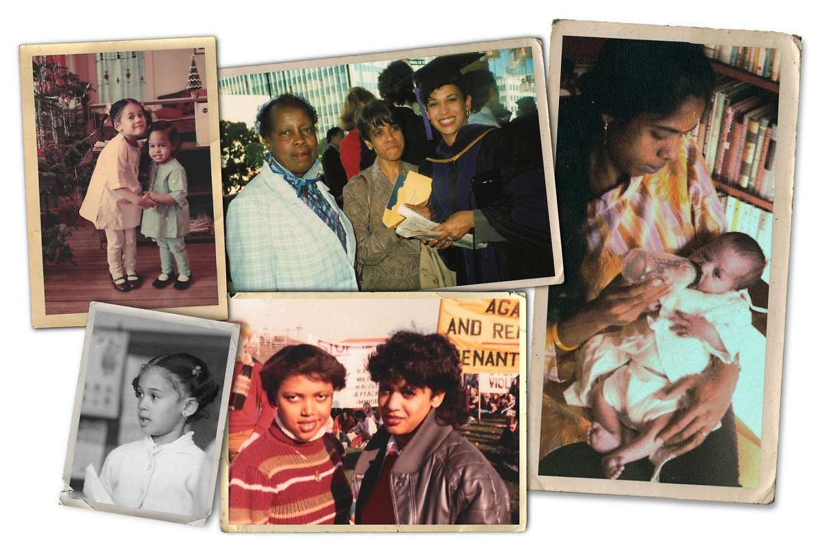
Clockwise from top left: Kamala Harris with her sister, Maya, on Christmas in 1968. Kamala Harris (right) graduates from UC Hastings College of the Law in 1989. Shyamala Gopalan Harris, 25, feeds her baby, Kamala. During Kamala Harris’ freshman year at Howard University in Washington, D.C., almost every weekend was spent at the Mall protesting apartheid and calling for divestment. Harris (right) stands with Gwen Whitfield in November 1982. An undated photo of Kamala Harris as a child. Photo: Chronicle Photo Collage With Images From Kamala Harris Campaign
It was after that disappointment that Gopalan moved to Canada to take a position at McGill University, when Harris was in middle school. Gopalan returned to Lawrence Berkeley for the last decade of her career, where Bissell had risen into leadership and was able to hire her.
Her mother wasn’t the only one on that side of the family who influenced Harris. In a recently re-published 2009 interview with India Abroad, an outlet for the U.S. Indian community, Harris said her mother made sure her daughters would be proud of their Indian heritage as well as their Black lineage — the part she knew American society would focus on.
Harris visited India often as a girl and was especially close to her grandfather, P.V. Gopalan, a high-ranking diplomat and former fighter for India’s independence from Britain.
“He would take walks every morning along the beach with his buddies, who were all retired government officials, and they would talk about politics, about how corruption must be fought and about justice,” Harris told the India Abroad interviewer. “They would laugh and voice opinions and argue, and those conversations, even more than their actions, had such a strong influence on me in terms of learning to be responsible, to be honest, and to have integrity.”
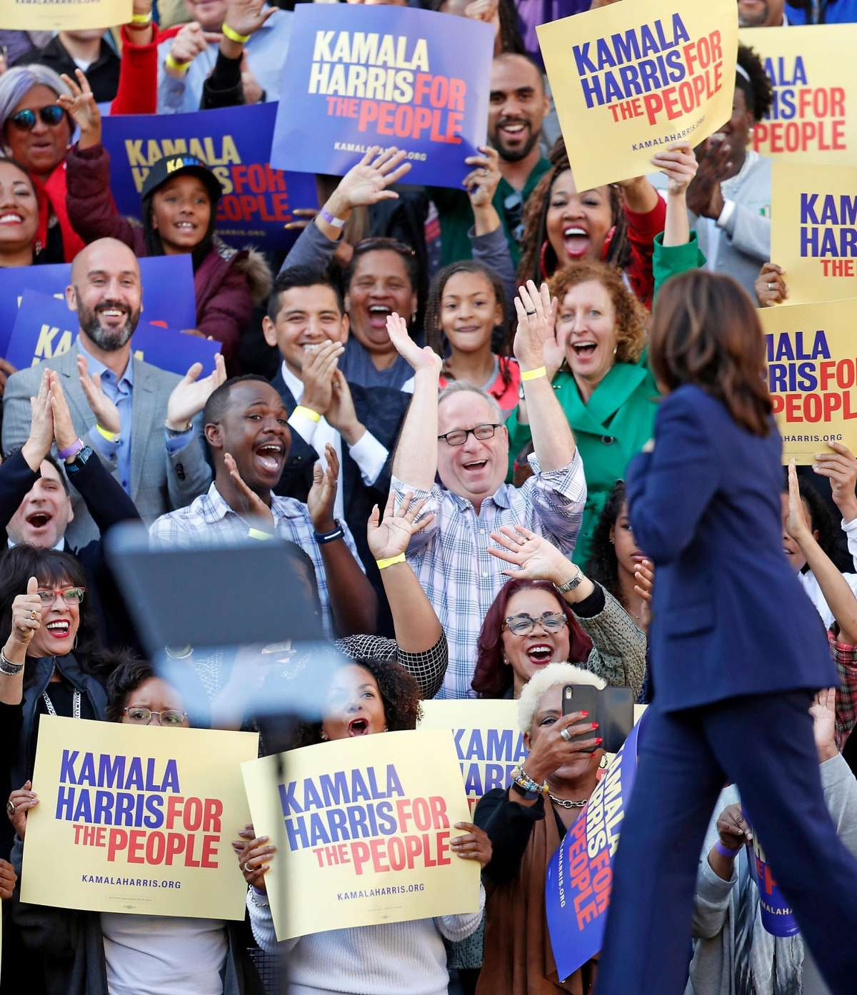
Sen. Kamala Harris arrives to kick off her presidential campaign at a rally at Frank Ogawa Plaza in Oakland in January 2019. Her East Bay roots have influenced who she is today. Photo: Scott Strazzante / The Chronicle 2019
When the interviewer asked if that was the true source of her activism — more than Berkeley — Harris said it was all of the above.
“It is important to not say one thing to the exclusion of the other, because I don’t feel the need to do that,” she said. “They are of equal weight in terms of who I am and the impact that they had on me growing up. My grandparents used to visit us in Berkeley all the time. My grandfather and grandmother enjoyed the time they spent with people of all walks of life who were involved in the civil rights movement.”
Berkeley schools have featured prominently in Harris’ political storytelling — including in a memorable flash point between Harris and her now-running mate in a presidential primary debate in June 2019.
Harris told the story of how she was among the first waves of students to integrate Berkeley schools, and criticized Biden for opposing desegregation busing in the 1970s and speaking highly of senators who had been vocal segregationists.
“There was a little girl in California who was part of the second class to integrate her public schools, and she was bused to school every day. And that little girl was me,” Harris said, in a phrase that her campaign marketed on T-shirts.
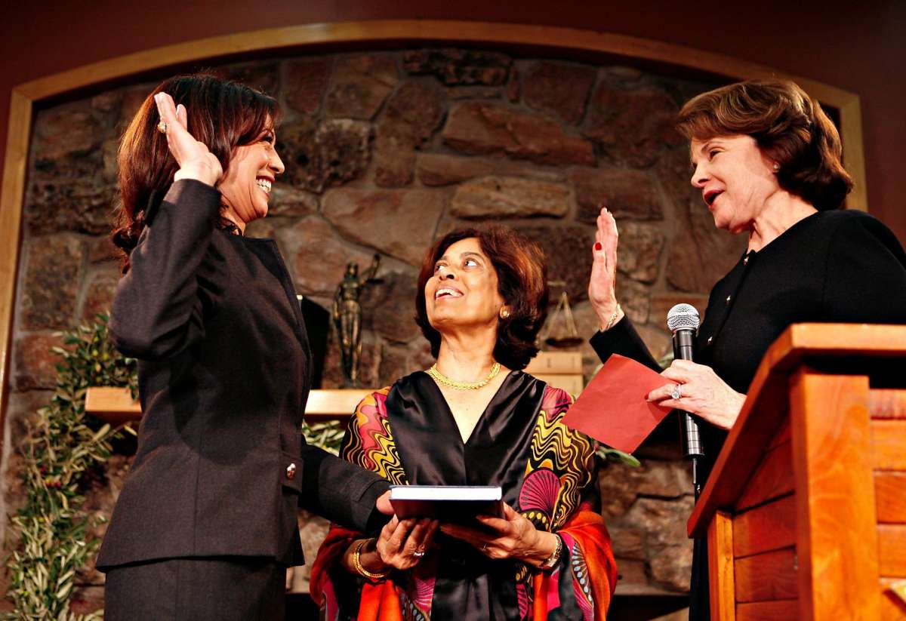
District Attorney Kamala Harris (left) with her hand on the Bible held by her mother, Shyamala Gopalan Harris, is sworn in by Sen. Dianne Feinstein for a second term in January 2008. Photo: Michael Maloney / The Chronicle 2008

Although the implication was that Harris might have faced discrimination or difficulty in that period, in her autobiography she describes a pleasant and intellectually stimulating upbringing in the area on the border of Berkeley and Oakland, surrounded by activists and people of all sorts of backgrounds.
“At the time, all I knew was that the big yellow bus was the way I got to school,” Harris wrote. “Looking at the photo from my first-grade class reminds of how wonderful it was to grow up in such a diverse environment. ... We were a varied bunch; some grew up in public housing, and others were the children of professors. I remember celebrating varied cultural holidays at school and learning to count to 10 in several languages.”
Schaaf said that “when you grow up in particularly Oakland and Berkeley in the ’70s, in the early ’80s, you are very comfortable with protest and you are very comfortable with challenging authority. You have a keen sense and comfort with the issue of racial justice. I can’t tell you how proud Oakland is to claim Kamala’s roots as the first Black woman vice president (candidate), the first Asian woman vice president, the first biracial vice president. Kamala has always lifted up her biracial identity — she’s never shied away from it.”
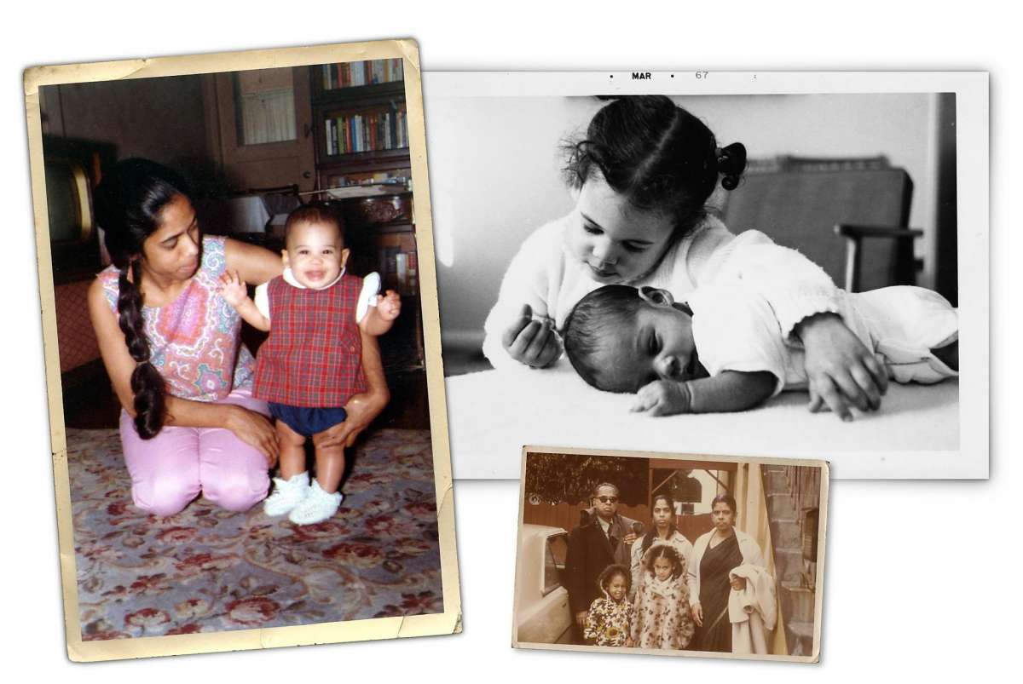
Clockwise from left: Shyamala Gopalan Harris holds her daughter, Kamala, in this undated photo. Kamala Harris and her sister, Maya, are pictured in March, 1967. Kamala Harris, center front, stands with her sister, Maya, mother, Shyamala, and her maternal grandparents in this undated photo. | Chronicle Photo Collage With Images From Kamala Harris Campaign
Harris is often asked to define her racial identity, which she usually does with a quip. At her January 2019 presidential campaign launch at her alma mater, Howard University, one of the nation’s most prominent historically Black universities, a reporter noted that Harris was both an African American and Indian American woman — “Indeed!” she replied — and asked how she would describe herself.
“How do I describe myself? I describe myself as a proud American, that’s how I describe myself,” she said.
That comfort with being multiracial is a signature of Oakland, said Aimee Allison, president of She the People, a group that works to promote women of color in politics. She is an Oakland resident and also biracial, the daughter of a white mother and Black father, who grew up in the Bay Area.
Allison said that what she sees in Harris — advocating for racial justice issues and comfortable in her own skin as a Black woman, an Indian American woman and the daughter of immigrants — is what she sees in her community today.
“The country may not know Oakland deeply in this way,” Allison said, “but that really comes from time in Oakland and the capacity to be around a lot of different people with a lot of different backgrounds. ... There’s a sense you can be lots of different things, you can have a complex, full identity.”
And, she said, “I think being from Oakland really prepares Kamala, and a lot of us, to lead and organize in the America of now: a multiracial America.”

Tal Kopan is The San Francisco Chronicle’s Washington correspondent. Email: tal.kopan@sfchronicle.com Twitter: @talkopan

