 | CLASS CALENDAR
Class |  | Class Content |  | Quizzes and Tests
Class 1 |  | Welcome!  Writing Skills – The Process, not the Product |  | Grammar Review: Section 1 – Sentence Structure p. 207-214  Grammar Review: Section 2 – Present, Past and Future Tenses p. 214-224
Class 2 |  | Overcoming Childhood – Memoir: Girls Gone Mild  Seminar 1 Explanations and Starting the Process |  | Grammar: Section 5  Passive and Reported Speech p. 241-244
Class 3 |  | Memoir: Girls Gone Mild and Kamala Harris  Seminar 1 Processing  Writing Skills – The body paragraph |  | Grammar: Section 10  Common Sentence Errors p. 268-273
Class 4 |  | Memoir: Girls Gone Mild and The Film Club  Seminar 1 Making the Process Vocal  Writing Skills – The body paragraph handed back  Speaking Skills – Convincing oral presentations |  | Formative Grammar and Rhetoric Test  FORMATIVE ESSAY
Class 5 |  | Formative Seminar Speech |  | Grammar and Rhetoric Test #1 (10%)
Class 6 |  | The Seminar 1: Overcoming Childhood – The Seminar Speech (20%)  The Seminar 1: Overcoming Childhood – The Seminar Essay (15%)  Essay
Class 7
Class 8
 |  | Reading Week
Class 9 |  | Midterms: Feedback  Seminar 2 Explanations  Overcoming Power: War and Money |  | Grammar: Section 12  Writing Style p. 278-283
Class 10 |  | Overcoming Power: Gender |  | Grammar: Section 4  Modals, Conditionals and Subjunctives p. 234-240
Class 11 |  | Overcoming Power: Race |  | Grammar: Section 3  The Perfect Aspect p. 225-233
Class 12 |  | Formative Seminar Speech |  | Grammar and Rhetoric Test #2 (15%)
Class 13 |  | Finals  The Seminar 2: Overcoming Power – The Seminar Speech (20%)
Class 14
Class 15 |  | Finals  The Seminar 2: Overcoming Power – The Seminar Essay (20%)
Exam Week |  | No exam

Class 1
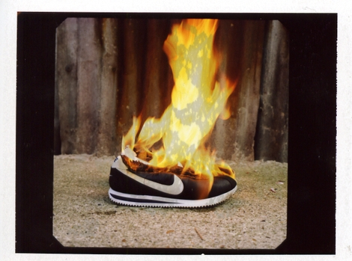
Have you ever wondered what other people think of you?
Do you think they all have the same opinion of you, or do opinions differ? Do your parents think of you in the same way as your grandparents do? What about your friends and your enemies?
As you probably already know, no two people share the same opinion of you. Opinions differ. It’s a matter of perspectives.

Perspectives are shaped by factors such as age, gender, wealth, culture, race, sexual orientation, etc., and positive and negative experiences that are uniquely our own. Who we are and what we are influence our opinions: they influence our perspectives.
Adapted from Perspectives Plus.

- Introduction

What is culture in global 21st century?
Is culture important?
Is literature Important?
What can the liberal arts teach us?

- Attendance
  - Opinion poll attendance p. 4 (this booklet) – choose one strongly agree and one strongly disagree and develop an answer in a short 150-word paragraph.

  - Ice Breaker and Opinion Poll Discussion

  - Course outline, objectives, expectations, evaluations, materials, MIO policy, Assignments, etc...

- Grammar Review (this handout)
Section 1 – Sentence Structure p. 207-214
Section 2 – Present, Past and Future Tenses p. 214-224

Assignments:

- Buy: Course Notes I (Course material to buy at Coopsco)
- Print the grammar booklet (Moodle)
- Log on: Moodle

Literature and culture:
- Read
Course Notes I – Girls Gone Mild pgs. 30-37 Answer key pgs. 142-150
  - Highlight college level vocabulary throughout the text

  - Close-Reading Reversed Classroom Assignment (p. 10-11 this booklet) Exercises 1-3

- Grammar:
Class 1 Handout
Review: Section 1 – Sentence Structure p. 207-214
Review: Section 2 – Present, Past and Future Tenses p. 214-224

Grammar Booklet
Grammar: Section 5 – Passive and Reported Speech p. 241-244
Answer Key on Moodle

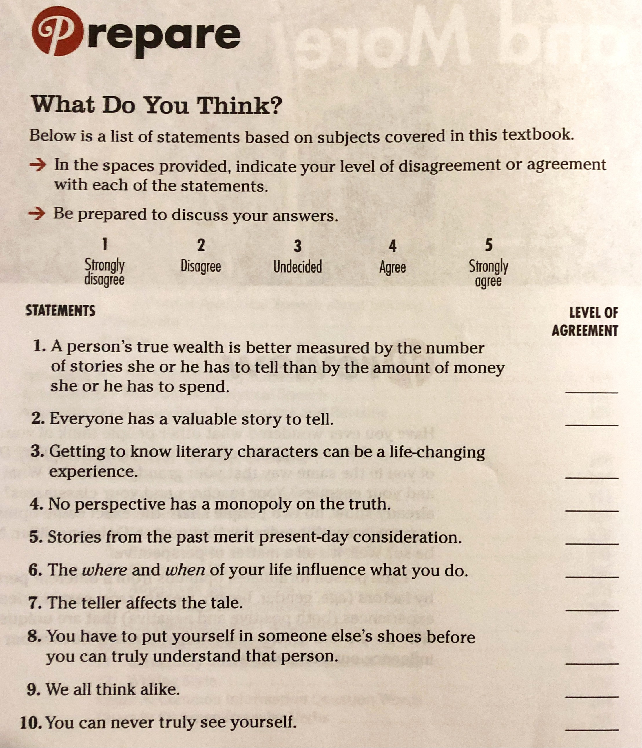

Why is Literature Important?
Part I – Through the Perspective of a Historical Figure
So, why is Literature important? How is it essential to a culture? Here's what William Long had to say...
Importance of Literature
It is a curious and prevalent opinion that literature, like all art, is a mere play of imagination, pleasing enough, like a new novel, but without any serious or practical importance. Nothing could be farther from the truth. Literature preserves the ideals of a people; and ideals--love, faith, duty, friendship, freedom, reverence--are the part of human life most worthy of preservation.

The Greeks were a marvellous people; yet of all their mighty works we cherish only a few ideals,--ideals of beauty in perishable stone, and ideals of truth in imperishable prose and poetry. It was simply the ideals of the Greeks and Hebrews and Romans, preserved in their literature, which made them what they were, and which determined their value to future generations.

Our democracy, the boast of all English-speaking nations, is a dream [an ideal]; not the doubtful and sometimes disheartening spectacle presented in our legislative halls, but the lovely and immortal ideal of a free and equal manhood, preserved as a most precious heritage in every great literature from the Greeks to the Anglo-Saxons. All our arts, our sciences, even our inventions are founded squarely upon ideals; for under every invention is still the dream of Beowulf, that man may overcome the forces of nature; and the foundation of all our sciences and discoveries is the immortal dream that men "shall be as gods, knowing good and evil."
In a word, our whole civilization, our freedom, our progress, our homes, our religion, rest solidly upon ideals for their foundation. Nothing but an ideal ever endures upon earth. It is therefore impossible to overestimate the practical importance of literature, which preserves these ideals from fathers to sons, while men, cities, governments, civilizations, vanish from the face of the earth.
(All formatting changes and added brackets are mine)
Source: About.com
http://classiclit.about.com/od/Experience_literature/a/The-Shell-And-The-Book_3.htm

Why is Literature Important?
Part II – Through the Perspective of a Female English Major by Paula Peters
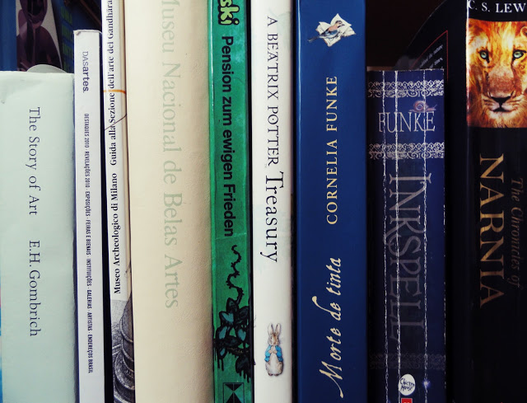
When I was in college, this question popped up a lot of times and most professors didn't seem to have a good answer for it. And I was a literature major, mind you.

Deep down, I always knew literature was quite important, not only for me or for professors but for everybody. Eventually I had to come up with an answer to give my friends who studied engineering. As a matter of fact, people from "practical" fields such as engineers, doctors, lawyers could always make us, insecure English majors, feel useless.

It amazed me to find engineers who actually appreciate literature and understand its importance while at the same time I heard literature professors saying the subject they teach had no real importance whatsoever.

With time, I've learn to find a couple of answers to why we should all study literature or at least read books. (By the way, I'm an advocate of reading good books and not necessarily a lot of books.) But these answers always came from other writers or thinkers.

The other day as I was reading Jane Austen's Persuasion I could find a more personal answer. The characters in this book are much less lovable than in other books such as Pride and Prejudice and Emma. Bottom line: it's difficult - if not impossible - to like them.
There's this one character, Mary, who is just so full of herself. She is so proud and thinks she is so much better than everyone else. And it's not charming pride, like Mr. Darcy's. It is ugly, mediocre and harmful pride.

Now, it's difficult for me to say this but, I saw a little bit of my own thoughts and behaviour in Mary. However, this is Ok. Because I could see that since what Mary does is uncalled for, lame and selfish - if my actions are similar to hers, they are also uncalled for, lame and selfish. With literature, or at least with good literature, we can see what we do as it really is. It's a wake up call.

This self examination can be done through a lot of different ways, not only literature. But sometimes, even if we are confronted with our own mistakes, we still feel that we are right. It's very difficult to admit that we are wrong, or selfish, or proud.

Inside our own heads we can always come up with some sort of excuse or justification for acting the way we do. But once you see someone doing the same things you do, suddenly it's not so pretty anymore. There is no excuse for the way Mary acts.
It's a little shocking, but it can produce changes. And I mean, life altering changes.
To tell you the truth, I was quite happy to figure out a more personal explanation to the importance of literature. Maybe if our college professors fail to provide us with a good answer, it's up to us - literature students and lovers, or as my Semantics professor said "language people" - to answer why literature matters.

What about you? What does literature mean to you?
You read. You understand. You grow. You evolve.
Why is Culture Important?
What defines culture in a world where one can eat McDonald’s in Tokyo after having bought a Louis Vuitton bag and Nike shoes in the afternoon and be at the other end of the world doing the same thing the very next day? Here is the identity problem as seen through the eyes of an artist.

Bonfire of the Brands – by Neil Boorman

On 26.08.06, I am going to gather every branded possession of mine into a warehouse, douse them with petrol and burn the lot. Jacobson chairs, Christian Dior shirts, a Louis Vuitton bag; I'm too frightened to calculate the financial cost of this action, but I know it's a lot. Far more unsettling than the money is the emotional cost I'm going to suffer. You see, it's not simply a pile of expensive clothes and accessories going on the bonfire, Neil Boorman is being destroyed too.
Until recently, I thought I knew who Neil Boorman was. I felt sure how the outside world regarded me because I had spent a fair amount of time engineering an image. I found the best way to understand and articulate 'me' was through the owning and displaying of things made by brands. They provided a source of comfort, a reassurance of my own self-worth; they project my identity to others around me.

Frustratingly, this attempt at branded self-identity has been accompanied with a numbed sense of dissatisfaction. Attempting to cure myself, I have sought comfort and reassurance by buying yet more branded goods, treating myself 'because I'm worth it'. I now understand that this behavior only made matters worse. For all the time and money I have devoted to collecting these brands, these symbols of self, I have absolutely no idea who I am. For every new material extension of my character, I become more distant from the person that I really am.

The reality however is only just becoming clear; with every new emblem of identity I add to my collection, I lose a piece of myself to the brands. They cannot reciprocate the love I give. They cannot transport me to the places I'm promised exist. I am not, nor will I ever be remotely similar to the people that appear in their ads. It is a lie, a lie I have believed in for too long.

Text by Neil Boorman found on blog below.
http://barnabys.blogs.com/neverhappened/2006/05/bonfire_of_the_.html

Proposition for English Culture and Communication

For this semester and hopefully for the rest of your life, I propose a better way to understand and articulate 'you' than through the owning and displaying of things made by brands. I propose that you spend a fair amount of time making “life altering changes,” “engineering” and “branding” yourself with imperishable opinions, ideas and ideals through the experience of literature and culture. Let your spoken and written voices project your identity onto others around you through these enduring manifestations.
Memoir: Girls Gone Mild
Reversed Classroom Assignment
Close-Reading Exercises
by Rupinder Gill Course Notes I pgs. 30-37

Exercise 1: Literary Devices
Using the glossary on Literary Devices (Course Notes I p.44-52), find one example in Memoir: Girls Gone Mild for each of the following literary devices:

Pun: __________________________________________________________________________________
Comedy: _______________________________________________________________________________
Allusion: _______________________________________________________________________________
Repetition: _____________________________________________________________________________
Metonym: _____________________________________________________________________________
Narrator (describe type): __________________________________________________________________
Metaphor: _____________________________________________________________________________
Hyperbole: _____________________________________________________________________________
Sarcasm: ______________________________________________________________________________

Exercise 2: Close Reading
Find at least 3 quotes in Memoir: Girls Gone Mild on one of the following themes:

- Family education
- “Mild” revolution or unfinished business or sowing one’s oats
- Fitting in (culture) - double identities
- Freedom from rules or adolescence

Exercise 3: Cultural References
Memoir: Girls Gone Mild is much about culture. Although the narrator has two cultures, we are made to feel she does not belong to any one of them.

Look up the meaning of all the cultural elements from the list below to help you understand the context of the story.
While some Canadian elements are still relevant today, others have been replaced by a modern equivalent. Find the contemporary equivalent of two (2) Canadian cultural references. Prepare a short 30-second explanatory nano-seminar on each one. You can use photos, audios, and videos (smart phones ok!). Post your findings on the forum (with links). These will be useful later when researching for essays.

Indian cultural references
 | Reference | Meaning | Contemporary Equivalent
1. | Rupee (41);
2. | Northern Punjab nunneries (50);
3. | kids playing with mud toys (58);
4. | Bollywood (73);
5. | Saag (76);
6. | Bhangra tracks (85);
7. | Samosa dough (96);

Canadian cultural references
 | Reference | Meaning | Contemporary Equivalent
1. | Spring Break (5);
2. | Maypoles (25);
3. | Welcome Back Kotter (31);
4. | Who’s the Boss? (32);
5. | 227 (32);
6. | Days of Our Lives (36);
7. | Labour Day (39);
8. | Richie and Joanie Cunningham; Happy Days characters (57);
9. | Walking-two-miles-to-go-to-school tale (59);
10. | Little league (120);
11. | Scrunchies; (146);
12. | Hypercolor (175);
13. | Mini Pop Kids albums (176);
14. | Kumbaya song (181);
15. | S’mores (182);
16. | Glengarry Glen Ross (185 “coffee is for closers” quote);
17. | Cosby kids (108);
18. | Mike Seaver; Growing Plains (146);
19. | Seinfeld (205);
20. | Doing the worm (217);

Exercise 4: Formal Analytical Essay Speech Topics
Course notes I pgs. 38-41
Using a Reader-Response Approach and a self-created analysis (Course Notes I p. 38), prepare a formal analytical speech on one of the following topics:
- Explain the pun in the title Memoir: Girls Gone Mild. What cultural references support this pun throughout Gill’s prologue? Support your answer with contextual and cultural elements from the text.
- Rumspringa is a period during which Amish adolescents are left to “sow their wild oats.” Why do you think the elders permit this? Does your culture have a Rumspringa? Should your culture have one? Support your answer with elements from Girls Gone Mild and The Film Club
- Discuss the reasons you agree or disagree with the following statement? Parents raise their children the way they themselves were raised. Support your answer with contextual and cultural elements from two of the follow texts: Girls Gone Mild, The Film Club, and Kamala Harris Shaped by Berkeley and a Do Something Mother:
- Why do people take stock of their lives when they turn twenty, thirty, forty, and so on? Support your answer with contextual and cultural elements from Girls Gone Mild and The Film Club.
- Take position for or against the following: You can never go back. Justify your answer by referring directly to Girls Gone Mild and The Film Club.
- Comment on the following, “The apple doesn’t fall far from the tree” is a proverb that means that a child grows up to be like his or her parents, by using two of the follow texts: Girls Gone Mild, The Film Club, and Kamala Harris Shaped by Berkeley and a Do Something Mother.

Exercise 5: Seminar Topics
Course Notes I pgs. 30-37
Using your knowledge from the speech you have given and researched, form an opinion on the following topics. Come prepared to present and discuss your opinions with that of the others. Quote examples from the texts.

- Is it possible to be childlike without being childish?
- When is childhood over?
- Is childhood beautiful?
- Can an adult experience Disney World or camp as a child would?
- Do adults care about childhood?
- Is childhood an erroneous modern concept?
- Can childhood memories affect the scope of adulthood?
- Is education overrated?
- Does culture play an important part in education?
- Does literature play an important part in education?

